Contoso Electronics Projects Next Year’s EARNINGS   
Press announcement

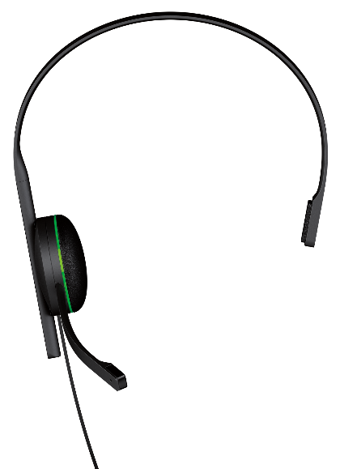

# For immediate release

**Seattle, WA** – Contoso today announced financial results for its most recent fiscal year. The Company posted quarterly revenue of $28.27 million and quarterly net profit of $6. 2 million, or $7.25 per diluted share. These results compare to revenue of $21.65 million and net quarterly profit of $4.45 million, or $4.74 per diluted share, in the year-ago quarter. Gross margin was 42.3 percent compared to 38.9 percent in the year-ago quarter. International sales accounted for 27 percent of the quarter’s revenue.   
  
  
“We are thrilled with the very strong finish of an outstanding fourth quarter, growing annual revenue to $108 million and growing earnings to $26 million,” said Patti Fernandez, Contoso’s CEO. “Customer response to our lines of consumer electronics has been fantastic, we have strong momentum going into the next quarter, and we remain really enthusiastic about our pipeline.”